Joel Chavali

1 August 2017

Molecular Dynamics

In this simulation, I modeled (5fdr_solv-cube_equil.pdb) at a target of 310 for 30,000 time steps. The model reached equilibrium at step 5,800 and had an average of 310.501 K for the rest of the time steps.

The graph below shows the stabilization of temperature at time step 5,800. The average temperature is 310.501 K and the standard deviation is 2.135 for temperature.

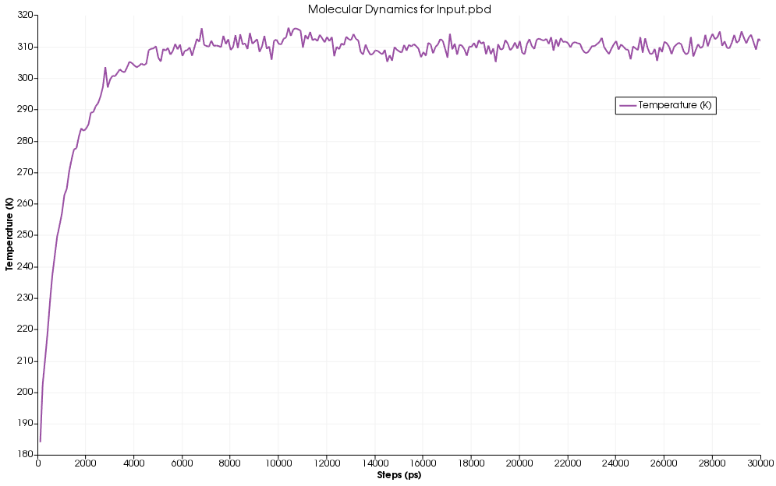  
The graph below shows the temperature and the kinetic energy stabilizing at 5,800 and verifies that temperature is correctly reflecting its relationship with kinetic energy.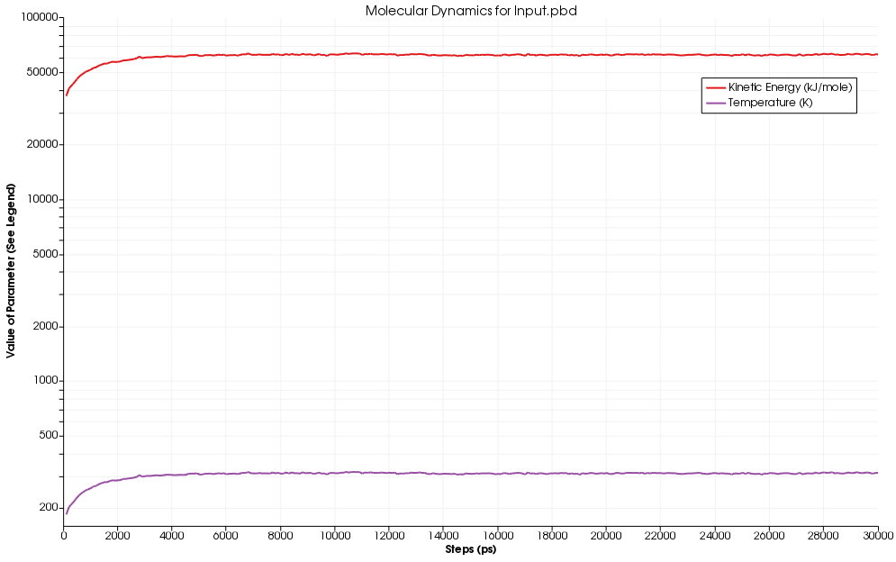

As the time goes on the energy of the system balances out and remains stable with the energy remaining stable after 5000 steps.

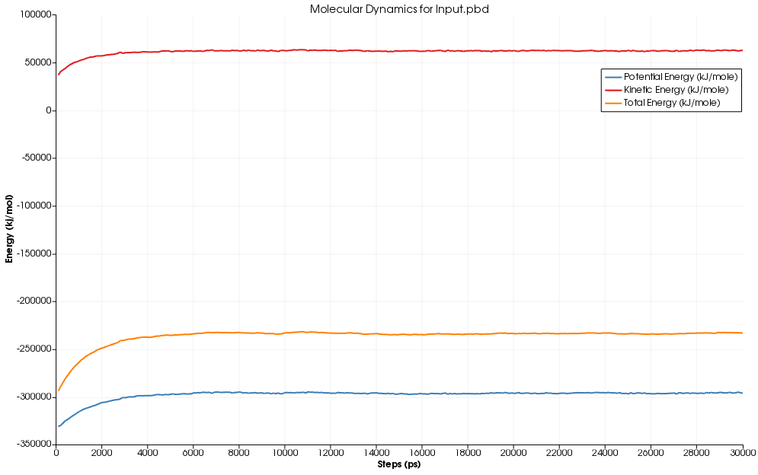

The density graph displays that the molecule remained spatially stable across all time steps.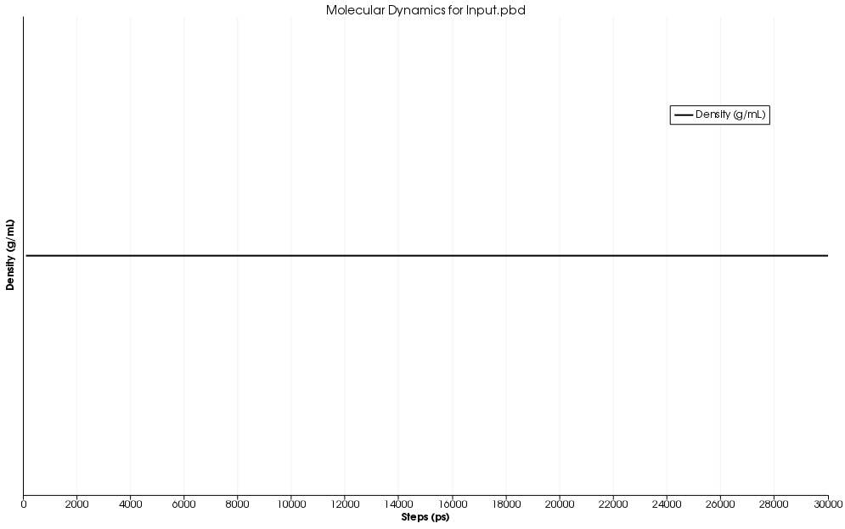

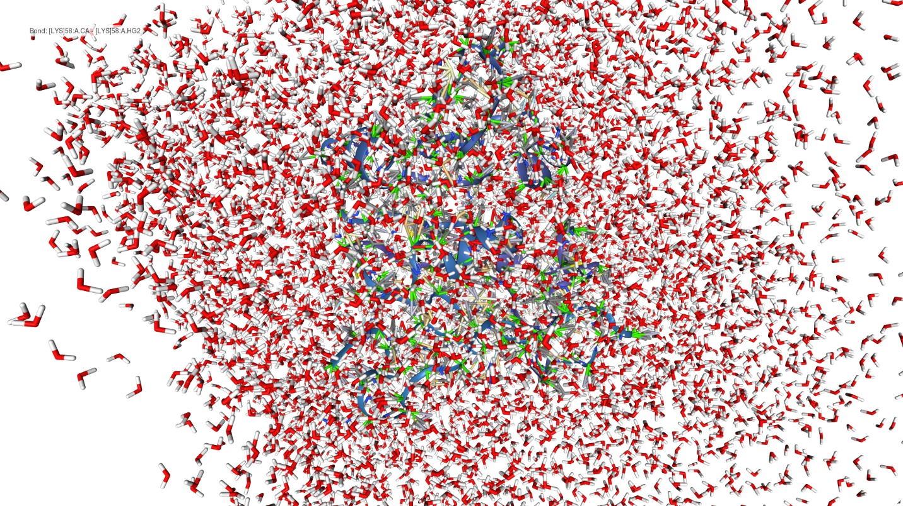And finally, here is the actual “wet” model in space while in equilibrium.